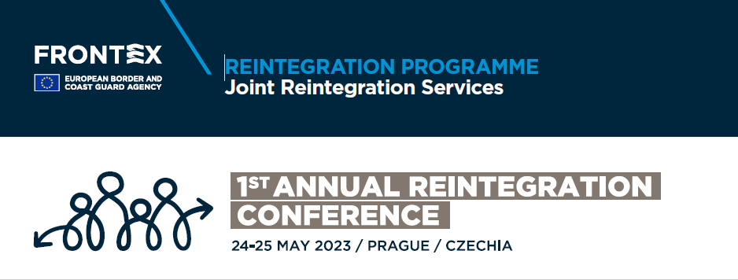

Annex 2

FACTSHEET TO BE SUBMITTED WITH THE PROPOSAL FOR A GRANT FOR A SPECIFIC COUNTRY OF RETURN

Please provide your answers for section 8, Selection Criteria, below.

Complete one form for each country of return you have received an invitation to apply for:

Country of return: ____________________

As described in section 8.2 Operational Capacity – for the above-mentioned country of return:

* curriculum vitae or description of the profile of the people primarily responsible for managing and implementing the operation;
* Organigram of the organisation to highlight the following:
  + Number of full-time equivalents (FTE) that the Reintegration Partner has to perform the activities related to this call
  + Formal structure with staff members assigned to
    - Contract management
    - Operations
    - Supporting services (HR, Finance)
  + Proportion (%) of staff working on the activities related to this call that have:
    - Social care profile
    - Management profile
    - Business/economic profile
    - Healthcare/psychotherapy profile
  + Proportion (%) of staff that has more than 2 years of experience in reintegration assistance planning
* A lists of previous projects and activities performed and connected to the provision of reintegration assistance; By providing this list of previous projects you hereby agree that Frontex can contact the project management teams and ask for references.

Also submit the following documents

* A copy of the certificate of official registration or other official document attesting the establishment of the entity in the particular country of return for which you were invited to submit a proposal;
* The supporting documents indicated for some of the indicators listed in the table below.

Check the box that applies:

|  |  |  |  |
| --- | --- | --- | --- |
|  | Description of indicator | Subcategory | Score |
|  | **Availability of services** |  |  |
| 1. | The organisation is willing to assist returnees after voluntary return by any means |  | YES  NO |
| 2. | The organisation is willing to assist returnees after non-voluntary return traveling by charter flights (meaning support to a large number of returnees at once, possibly 25-75, or more, at a time) |  | YES  NO |
| 3. | The organisation is willing to assist returnees after non-voluntary return by regular means of transport, scheduled flights, etc |  | YES  NO |
| 4. | The organisation is willing to deploy reintegration counsellors, from its own staff to the MS |  | YES  NO |
|  | **Accessibility – Physical presence** |  |  |
| 5. | The RP/LRP has an office in the capital of the country of return   * A copy of the Rental/Ownership Agreement to be submitted, valid at the time of submission |  | YES  NO |
| 6. | The RP/LRP has offices outside the capital of the country of return   * A copy of the Rental/Ownership Agreement for 30% of the number of locations to be submitted, valid at the time of submission | Between 1 and 5 offices | YES  NO |
|  | * A copy of the Rental/Ownership Agreement for 30% of the number of locations to be submitted, valid at the time of submission | Between 5 and 10 offices | YES  NO |
|  | * A copy of the Rental/Ownership Agreement for 30% of the number of locations to be submitted, valid at the time of submission | More than 10 offices | YES  NO |
| 7. | The RP/LRP has a process to cover reintegration assistance in areas where it does not have an office |  | YES  NO |
|  | **Accessibility – Opening hours** |  |  |
| 8. | Number of hours per week that the RP/LRP is open for returnees | Less than 20 hours/week | YES  NO |
|  |  | More than 20 hours/week | YES  NO |
| 9. | The RP/LRP allows for returnees to walk into the office without prior appointment |  | YES  NO |
| 10. | The RP/LRP can secure in-person appointments/contacts at the offices with returnees before or after normal working hours. |  | YES  NO |
|  | **Accessibility – Contact channels** |  |  |
| 11. | The Local Reintegration Partner can accommodate digital meetings with returnees |  | YES  NO |
| 12. | The Local Reintegration Partner can accommodate digital meetings with returnees before or after normal working hours |  | YES  NO |
| 13. | The contact details that the RP/LRP provides are functional |  | YES  NO |
|  | **Physical Infrastructure** |  |  |
| 14. | Availability of power supply (average for all locations) | Less than 2 hours/day | YES  NO |
|  |  | More than 2 hours/day | YES  NO |
| 15. | Availability of Internet access (average for all locations) | Less than 2 hours/day | YES  NO |
|  |  | More than 2 hours/day | YES  NO |
| 16. | Ability to organise Airport reception and pick-up within 5 days after the request |  | YES  NO |
|  | **Network/Embeddedness of the RP/LRP**  List of organisations that the Reintegration Partner has a documented operational relationship within the field of (local/regional/national) to be included if the answer is yes to any of the following |  |  |
| 17. | Embeddedness with employment services   * A copy of Contract/Memorandum of Understanding with at least 1 partner to be submitted | 1 partner and above | YES  NO |
| 18. | Embeddedness with local education services   * A copy of Contract/Memorandum of Understanding with at least 1 partner to be submitted | 1 partner and above | YES  NO |
| 19. | Embeddedness with local health services   * A copy of Contract/Memorandum of Understanding with at least 1 partner to be submitted | 1 partner and above | YES  NO |
| 20. | Embeddedness with local administrative services   * A copy of Contract/Memorandum of Understanding with at least 1 partner to be submitted | 1 partner and above | YES  NO |
| 21. | Embeddedness with local government / authorities   * A copy of Contract/Memorandum of Understanding with at least 1 partner to be submitted | 1 partner and above | YES  NO |
| 22. | Embeddedness with local NGO / civil society networks   * A copy of Contract/Memorandum of Understanding with at least 1 partner to be submitted | 1 partner and above | YES  NO |
|  | **Organisational Background** |  |  |
| 23. | Local presence of the Local Reintegration Partner in the country of return – documented number of years in the country of return | Between 3 and 5 years | YES  NO |
|  |  | More than 5 years | YES  NO |
| 24. | Number of years that the organisation has implemented activities in the area of reintegration (not necessarily after return, can also include Internally Displaced or similar).   * Copy of contracts/financing/project to confirm to be submitted | Between 3 and 5 years | YES  NO |
|  | * Copy of contracts/financing/project to confirm to be submitted | More than 5 years | YES  NO |
| 25. | Number of years that the organisation has implemented activities in the area of reintegration after return from the EU.   * Copy of contracts/financing/project to confirm to be submitted | Between 3 and 5 years | YES  NO |
|  | * Copy of contracts/financing/project to confirm to be submitted | More than 5 years | YES  NO |
| 26. | Organisation has an internal monitoring and control system, incl. early warning, to detect any disruption in the continuity or quality of local service delivery   * Copy of guidelines/standards operating procedure to be submitted |  | YES  NO |
| 27. | Organisation has internal guidelines on the management of a reintegration case, the inception of a reintegration plan, the financial justification of expenses and overall reporting requirements.   * Copy of guidelines/standards operating procedure to be submitted |  | YES  NO |
| 28. | Number of reintegration cases after return that the RP/LRP has managed over the last 3 years (average) in that particular country of return. | Less than 25 cases/year | YES  NO |
|  |  | Between 25 and 100 and over cases/year | YES  NO |
|  |  | More than 100 cases/year | YES  NO |
| 29. | Budget that the RP/LRP has spent on reintegration projects after return over the last 3 years (average) – only for the country of origin in question.   * Copy of contracts/contribution agreements to be submitted. Alternatively, bank records could be submitted. | Less than EUR 60.000/year | YES  NO |
|  |  | Between EUR 60,000 and EUR 750,000 / year | YES  NO |
|  |  | Over EUR 750,000 / year | YES  NO |

In addition to the above-mentioned YES/NO answers, please provide answers to the following 5 questions. The answers will be evaluated by the selection committee and given a value of between 0 and 20 points each. Please keep the answers as short as possible without detriment to the quality of the answer, but no longer than 100 words.

* Please describe the steps you take to provide reintegration assistance to returnees, starting from the initial contact, going through the entire process, including meetings, evaluation of requirements stated by the returnee, planning, amending, referrals, monitoring of the process and finishing with the case closure and final reporting.
* Please indicate how you would provide reintegration assistance to a returnee that lives in an area that is not covered physically by an office.
* Please indicate the process of evaluating the need for specialised assistance for vulnerable persons including but not limited to unaccompanied minors, single women, victims of trafficking, the elderly, etc.
* Please indicate what particular challenges you have encountered in providing reintegration assistance in this country of return and what steps you have taken to overcome them.
* Please explain how the COVID pandemic has affected your operations in this country of return and what steps you have taken to ensure uninterrupted assistance to the returnees.